**OVERVIEW OF DB:**

**What is a Database?**

A database refers to a collection of logically related information organized so that it can be easily accessible, managed, and updated. Databases are generally accessed electronically from a computer system and are usually controlled by a database management system (DBMS). The database administrator (DBA) is the individual responsible for managing the databases, including database security, access control, backup, and disaster recovery.

# Why do we need a Database:

A database is a collection of data, usually stored in electronic form. A database is typically designed so that it is easy to store and access information.

A good database is crucial to any company or organisation. This is because the database stores all the pertinent details about  the company such as employee records, transactional records, salary details etc.

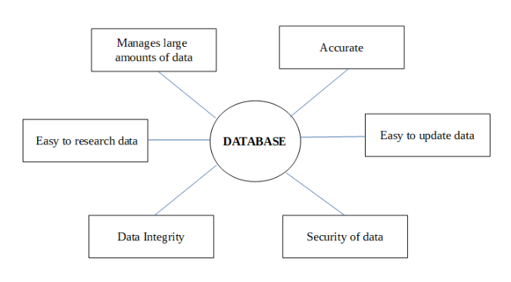

The various reasons a database is important are −

## Manages large amounts of data

A database stores and manages a large amount of data on a daily basis. This would not be possible using any other tool such as a spreadsheet as they would simply not work.

## Accurate

A database is pretty accurate as it has all sorts of build in constraints, checks etc. This means that the information available in a database is guaranteed to be correct in most cases.

## Easy to update data

In a database, it is easy to update data using various Data Manipulation languages (DML) available. One of these languages is SQL.

## Security of data

Databases have various methods to ensure security of data. There are user logins required before accessing a database and various access specifiers. These allow only authorised users to access the database.

## Data integrity

This is ensured in databases by using various constraints for data. Data integrity in databases makes sure that the data is accurate and consistent in a database.

## Easy to research data

It is very easy to access and research data in a database. This is done using Data Query Languages (DQL) which allow searching of any data in the database and performing computations on it.

### Purpose of Database System:

In DBMS, database systems provide a safe and effective platform to manage vast amounts of data. Their role is to provide services like data organization, storage, and manipulation, as well as to guarantee data integrity. A database system’s primary goal is to facilitate data retrieval and provide a dependable storage platform for essential data.

* Efficient storage and retrieval are allowed by structured organization of data through database systems utilizing predefined schemas and data models.
* DBMS maintains the reliability and accuracy of the information and returns it through enforced constraints and rules defined in the database schema that eliminates data redundancy and anomalies, respectively.
* Protecting confidential data is crucial and database systems successfully achieve this with their safeguards against unauthorized access.
* Database systems prioritize the security of sensitive data with their solid mechanisms in place to preserve data confidentiality.
* The inclusion of strong security measures in database systems ensures the protection of sensitive data and upholds its confidentiality. Confidentiality and privacy of data are maintained by utilizing resilient security measures within database systems.
* Collaboration made easy with DBMS. With the provision of a platform to access and manipulate data, multiple users can now work together and ensure data consistency across various applications. Data sharing and collaboration are now synonymous with the help of DBMS.
* Data backups and transaction management are mechanisms provided by database systems to ensure data durability. Safeguarding data against system crashes and failures is their main priority

# classification of Databases:

There are various types of databases used for storing different varieties of data:

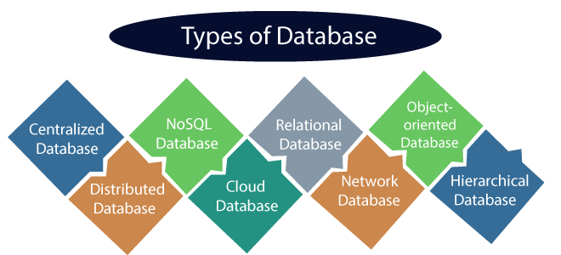

## 1) Centralized Database

It is the type of database that stores data at a centralized database system. It comforts the users to access the stored data from different locations through several applications. These applications contain the authentication process to let users access data securely. An example of a Centralized database can be Central Library that carries a central database of each library in a college/university.

### Advantages of Centralized Database

* It has decreased the risk of data management, i.e., manipulation of data will not affect the core data.
* Data consistency is maintained as it manages data in a central repository.
* It provides better data quality, which enables organizations to establish data standards.
* It is less costly because fewer vendors are required to handle the data sets.

### Disadvantages of Centralized Database

* The size of the centralized database is large, which increases the response time for fetching the data.
* It is not easy to update such an extensive database system.
* If any server failure occurs, entire data will be lost, which could be a huge loss.

## 2) Distributed Database

Unlike a centralized database system, in distributed systems, data is distributed among different database systems of an organization. These database systems are connected via communication links. Such links help the end-users to access the data easily. **Examples** of the Distributed database are Apache Cassandra, HBase, Ignite, etc.

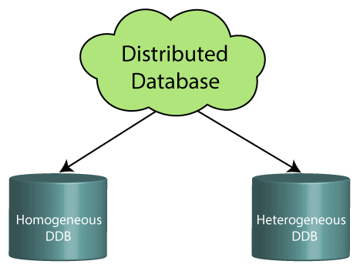

* **Homogeneous DDB:** Those database systems which execute on the same operating system and use the same application process and carry the same hardware devices.
* **Heterogeneous DDB:** Those database systems which execute on different operating systems under different application procedures, and carries different hardware devices.

### Advantages of Distributed Database

* Modular development is possible in a distributed database, i.e., the system can be expanded by including new computers and connecting them to the distributed system.
* One server failure will not affect the entire data set.

## 3) Relational Database

This database is based on the relational data model, which stores data in the form of rows(tuple) and columns(attributes), and together forms a table(relation). A relational database uses SQL for storing, manipulating, as well as maintaining the data. E.F. Codd invented the database in 1970. Each table in the database carries a key that makes the data unique from others. **Examples** of Relational databases are MySQL, Microsoft SQL Server, Oracle, etc.

### Properties of Relational Database

There are following four commonly known properties of a relational model known as ACID properties, where:

**A means Atomicity:** This ensures the data operation will complete either with success or with failure. It follows the 'all or nothing' strategy. For example, a transaction will either be committed or will abort.

**C means Consistency:** If we perform any operation over the data, its value before and after the operation should be preserved. For example, the account balance before and after the transaction should be correct, i.e., it should remain conserved.

**I means Isolation:** There can be concurrent users for accessing data at the same time from the database. Thus, isolation between the data should remain isolated. For example, when multiple transactions occur at the same time, one transaction effects should not be visible to the other transactions in the database.

**D means Durability:** It ensures that once it completes the operation and commits the data, data changes should remain permanent.

## 4) NoSQL Database

Non-SQL/Not Only SQL is a type of database that is used for storing a wide range of data sets. It is not a relational database as it stores data not only in tabular form but in several different ways. It came into existence when the demand for building modern applications increased. Thus, NoSQL presented a wide variety of database technologies in response to the demands. We can further divide a NoSQL database into the following four types:

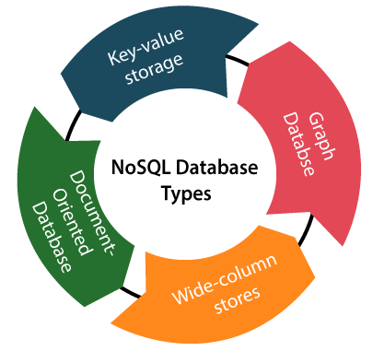

1. **Key-value storage:** It is the simplest type of database storage where it stores every single item as a key (or attribute name) holding its value, together.
2. **Document-oriented Database:** A type of database used to store data as JSON-like document. It helps developers in storing data by using the same document-model format as used in the application code.
3. **Graph Databases:** It is used for storing vast amounts of data in a graph-like structure. Most commonly, social networking websites use the graph database.
4. **Wide-column stores:** It is similar to the data represented in relational databases. Here, data is stored in large columns together, instead of storing in rows.

### Advantages of NoSQL Database

* It enables good productivity in the application development as it is not required to store data in a structured format.
* It is a better option for managing and handling large data sets.
* It provides high scalability.
* Users can quickly access data from the database through key-value.

## 5) Cloud Database

A type of database where data is stored in a virtual environment and executes over the cloud computing platform. It provides users with various cloud computing services (SaaS, PaaS, IaaS, etc.) for accessing the database. There are numerous cloud platforms, but the best options are:

* Amazon Web Services(AWS)
* Microsoft Azure
* Kamatera
* PhonixNAP
* ScienceSoft
* Google Cloud SQL, etc.

## 6) Object-oriented Databases

The type of database that uses the object-based data model approach for storing data in the database system. The data is represented and stored as objects which are similar to the objects used in the object-oriented programming language.

## 7) Hierarchical Databases

It is the type of database that stores data in the form of parent-children relationship nodes. Here, it organizes data in a tree-like structure.

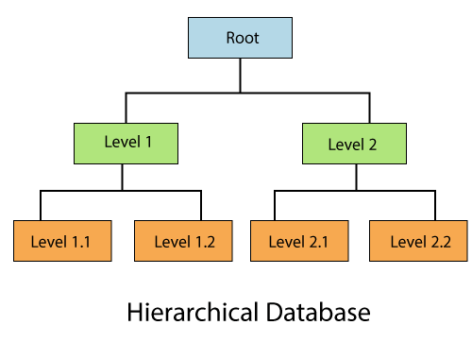

Data get stored in the form of records that are connected via links. Each child record in the tree will contain only one parent. On the other hand, each parent record can have multiple child records.

## 8) Network Databases

It is the database that typically follows the network data model. Here, the representation of data is in the form of nodes connected via links between them. Unlike the hierarchical database, it allows each record to have multiple children and parent nodes to form a generalized graph structure.

## 9) Personal Database

Collecting and storing data on the user's system defines a Personal Database. This database is basically designed for a single user.

### Advantage of Personal Database

* It is simple and easy to handle.
* It occupies less storage space as it is small in size.

# Application of DBMS:

1. **Railway Reservation System –**  
   In the rail route reservation framework, the information base is needed to store the record or information of ticket appointments, status about train’s appearance, and flight. Additionally, if trains get late, individuals become acquainted with it through the information base update.
2. **Library Management System –**  
   There are lots of books in the library so; it is difficult to store the record of the relative multitude of books in a register or duplicate. Along these lines, the data set administration framework (DBMS) is utilized to keep up all the data identified with the name of the book, issue date, accessibility of the book, and its writer.
3. **Banking –**  
   Database the executive’s framework is utilized to store the exchange data of the client in the information base.
4. **Education Sector –**  
   Presently, assessments are led online by numerous schools and colleges. They deal with all assessment information through the data set administration framework (DBMS). In spite of that understudy’s enlistments subtleties, grades, courses, expense, participation, results, and so forth all the data is put away in the information base.
5. **Credit card exchanges –**  
   The database Management framework is utilized for buying on charge cards and age of month to month proclamations.
6. **Social Media Sites –**  
   We all utilization of online media sites to associate with companions and to impart our perspectives to the world. Every day, many people group pursue these online media accounts like Pinterest, Facebook, Twitter, and Google in addition to. By the utilization of the data set administration framework, all the data of clients are put away in the information base and, we become ready to interface with others.
7. **Broadcast communications –**  
   Without DBMS any media transmission organization can’t think. The Database the executive’s framework is fundamental for these organizations to store the call subtleties and month to month postpaid bills in the information base.
8. **Account –**  
   The information base administration framework is utilized for putting away data about deals, holding and acquisition of monetary instruments, for example, stocks and bonds in a data set.
9. **Online Shopping –**   
   These days, web-based shopping has become a major pattern. Nobody needs to visit the shop and burn through their time. Everybody needs to shop through web based shopping sites, (for example, Amazon, Flipkart, Snapdeal) from home.

1. **Human Resource Management –**   
   Big firms or organizations have numerous specialists or representatives working under them. They store data about worker’s compensation, assessment, and work with the assistance of an information base administration framework (DBMS).
2. **Manufacturing –**   
   Manufacturing organizations make various kinds of items and deal them consistently. To keep the data about their items like bills, acquisition of the item, amount, inventory network the executives, information base administration framework (DBMS) is utilized.
3. **Airline Reservation System –**   
   This framework is equivalent to the railroad reservation framework. This framework additionally utilizes an information base administration framework to store the records of flight takeoff, appearance, and defer status.
4. **Healthcare:**DBMS is used in healthcare to manage patient data, medical records, and billing information.

## Main Features of a DBMS:

An efficient database management system tool should include the following features:

### ****Data Normalization****

The risk of data duplication in a database is relatively high as multiple users share it simultaneously. Data normalization mitigates this risk and minimizes the chance of destructive anomalies appearing. No data redundancy and repetition save storage and significantly improve access time.

### ****Rules and constraints defined by users****

Referential Integrity constraints help organizations prevent accidental damage to the database by authorized users. Database management software allows users to define validation and integrity rules and conditions to ensure data satisfies the semantics.

### ****Security protocols****

Security controls protect the integrity of a database and the data and records residing in it. Some essential DBMS security controls include data encryption, user authentication, and user authorization.

### ****Data backup****

A backup protects your database against data loss. A copy of files stored in a database must be available to reconstruct data in case data get lost or corrupted. Most DBMSs support logical and physical data backup.

### ****Data structuring****

A DBMS must allow users to organize information in a database in a clear hierarchical structure. It means all objects, records, and tables can be arranged correctly, like a catalog, to access and retrieve the records easily.

# components of DBMS:

**Hardware**

The hardware is the actual computer system used for keeping and accessing the database. The conventional DBMS hardware consists of secondary storage devices such as hard disks. Databases run on the range of machines from micro computers to mainframes.

**Software**

Software is the actual DBMS between the physical database and the users of the system. All the requests from the user for accessing the database are handled by DBMS.

**Data**

It is an important component of the database management system. The main task of DBMS is to process the data. Databases are used to store the data, retrieved, and updated to and from the databases.

**Users**

There are a number of users who can access or retrieve the data on demand using the application and the interfaces provided by the DBMS.

The users of the database can be classified into different groups −

* Native Users
* Online Users
* Sophisticated Users
* Specialized Users
* Application Users
* DBA- Database Administrator

The components of DBMS are given below in pictorial form –

